Graduate Student Seminars in Pharmaceutical Sciences

SRM3333 (MSc) & SRD4444 (PhD)

Course Description:
This required course involves attendance, presentation, and chairing seminars within the Biomedical Sciences (BMS) or Clinical, Social and Administrative Pharmaceutical Sciences (CSAP) fields. The course serves as a platform for the dissemination and discussion of current research underway by graduate students in the Department of Pharmaceutical Sciences.

Field¹ | SubGroup² | Coordinator | Participant PIs | Number of Trainees | Course Support
BMS | A | Pang, KS | Bendayan  Chalikian  Kotra  Hampson  Henderson  Pang  Reilly  Weaver  Wu | 34 | Delphine Zheng  luyan.zheng@utoronto.ca
BMS | B | Wells, PG | Bonin  Cummins  Labouta  Li  Macgregor  Pardee  Wells, PG | 31 | Sitra Mohamed  Sitra.mohamed@utoronto.ca
BMS | C | Lee, P | Allen  Angers  Kelley  Lee  Piquette  Uetrecht  Zheng | 30 | Sitra Mohamed  Sitra.mohamed@utoronto.ca
CSAP | HSPR/CR | Thompson, A | Austin  Battistella  Boon  Cadarette  Chit  DeAngelis  Dolovich  Dupuis  Gomes  Grootendorst  Guilcher  Kohler  McCarthy  Papadimitropoulos  Seto  Steenhof  Swidrovich  Sproule  Taddio  Thompson | 37 | Delphine Zheng  luyan.zheng@utoronto.ca
¹BMS, Biomedical Sciences; CSAP, Clinical Social and Administrative Pharmacy
²CR, Clinical Research; HSPR, Health Services and Policy Research
Course Objectives:

  - Promote awareness and understanding of the work undertaken by different research groups within the Biomedical sciences (BMS) or Clinical, Social and Administrative Pharmaceutical (CSAP) sciences
  - Provide opportunity for interaction and collaboration among graduate students and faculty members
  - Provide students with an opportunity to organize and present their research, enhance oral communication skills, develop their ability to defend their ideas in a public forum; and the opportunity to give and receive feedback.
  - Provide students the opportunity to act as the Chair of the session, gain experience introducing a speaker and moderating the question period.

Course Requirements:
Course requirements are summarized in Table 1.
Table 1. Minimum requirements EACH* academic year enrolled in the graduate program
Seminar Type and Expectations | Graduate Student Status
Seminar Type and Expectations | Full-time (FT) | Part-time (PT)
- Departmental Seminars  - attendance minimum** | 8 | 4
- Student Seminars
- attendance minimum | 8 | 4
- chair | 1 | 1
- present | 1 | 1
*students MUST present each year they are enrolled in the graduate program, yet have the option to opt out of presenting in the student seminar should they book their EXIT seminar (PhD Oral Defense that is part of the Departmental Seminar series) before the final date to submit their thesis for the fall (September 29, 2023)
**half of the Departmental seminar quota (4 FT, 2 PT) may be through attendance of sanctioned external seminars
Attendance will be tracked by the course coordinator AND only count after students have completed all questions on the evaluation forms for each presenter.

Student Seminar Presentation Format:

Each student will be allotted a maximum of 30 minutes*
- Presentation: 18 to 20** min, timed by the chair
- Questions and discussions: ~10 minutes
*it is imperative that presentations are well rehearsed and timed within the maximum time allotted, and that chairs and presenters test slides prior to the beginning of each seminar
**Students in their first year may present 10 min seminars.

Style and Content:
- Similar in style and content to those commonly given at scientific meetings
  - title, disclosures*, background, rationale, methods, results, discussion, conclusions, and significance
*if applicable
- Slides
  - avoid unnecessary acronyms or detail that requires expert knowledge on the part of the audience
  - clear and understandable on standard laptop (virtual presentations) and from the back of the room (in person presentations)

Responsibilities of Presenting Students:

- Prepare and submit a biography and presentation abstract
  - Please see bio and abstract template at the end of this document
  - Submit to course support (who will post on Quercus) minimum 1 week prior to presentation

- Arrive 15 minutes early to seminar room on presentation date to troubleshoot / ensure all is in working order

- Give 18 to 20-minute presentation suitable for everyone in the audience
  - The story should be intelligible to everyone present, especially those not working in the field
  - Seminars should be prepared with care and rehearsed to ensure that they are clear and properly timed within the maximum allotted time.

- Answer questions from the audience related to your presentation

NB: If a presentation is deemed unacceptable by the Coordinator(s), the student must present a second seminar during the same academic year.

Responsibilities of Student Chairs:

- Arrive 15 min before the start of the seminar to ensure that everything is in order, e.g.,
  - On-line: no technology issues (contact course support if an issue is found).
  - In person:
    - room is organized, tidy and chairs are facing the screen
    - upload slides and ensure functionality
    - computer and projector work

- Introduce the speaker, giving a brief biography (read the bio provided by presenter, or shorten if lengthy)

- Ensure that the speaker keeps within the designated time limit
  - If the speaker is not adhering to time, the chair needs to signal to them to wrap up.

- Encourage and moderate the discussion
  - give students first priority for asking questions
  - have questions ready for the speaker in the event that nothing is forthcoming from the audience
  - end the discussion at or before the maximum 30 minute mark

- Remind students to complete the Evaluation Form for each speaker

Student Seminar Evaluation:

All students will provide written feedback to peers by completing the evaluation form for each student presenter in Quercus.

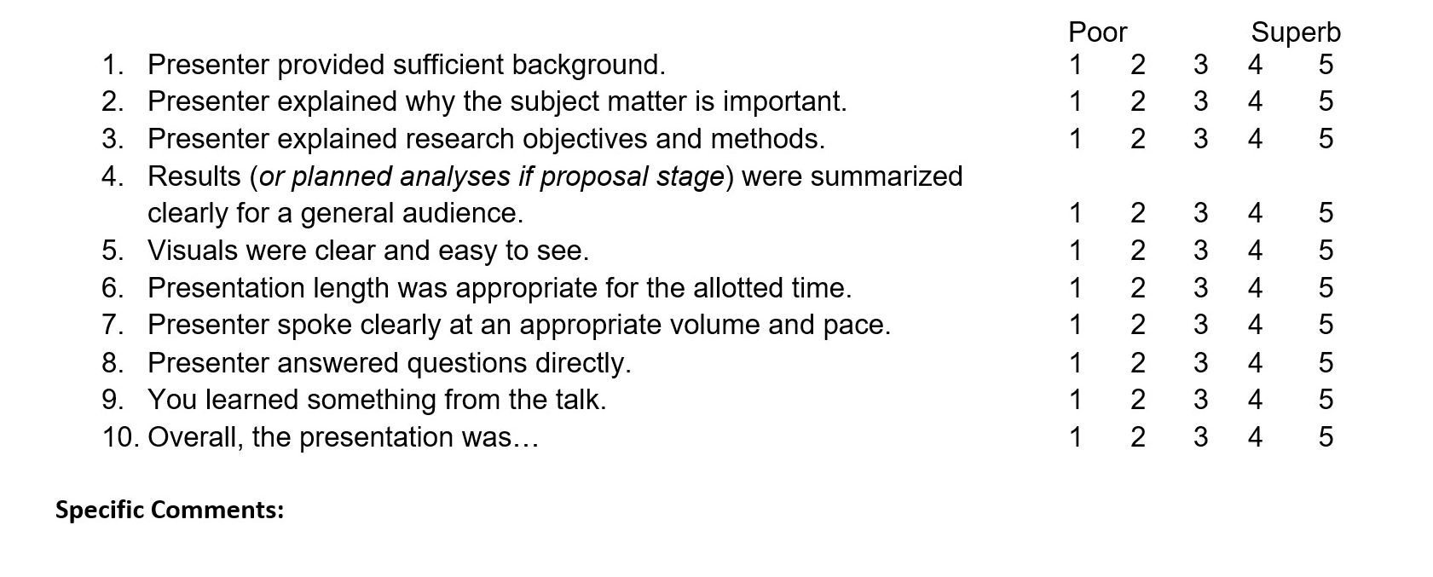
Results from the evaluation forms are used to
- Provide feedback to student presenters to share and discuss with their supervisor(s), and
- Inform selection of the GRIP seminar award winners
In addition to providing feedback to students, the evaluation forms are required to receive credit for attendance in each seminar! Please refer to Table 1 for minimum attendance requirements for each academic year.

Presenter Bio and Abstract Template
Presenting Author Information:
Name: <name of graduate student presenting the research>
Level: <indicate either: MSc Student, PhD Student or PhD candidate*>
*PhD candidate=qualifying or transfer exam complete + minimum number of required courses complete + minimum GRIP presentations complete (NB: there is no such thing as “MSc candidate”)

Supervisor(s): <name(s) of graduate student supervisor(s)>

Advisory Committee Members(s): <name(s) of advisory committee member(s)>

Brief Presenter Bio

This is not a life history, yet please do mention using freeform text in a style that the chair can read:
- Training history (e.g., prior earned degrees and location)
- Prior or current relevant work experience
- Current graduate training awards / honours

Word count: xxx (max 100)

Compose your abstract using Arial size 9 font, single line spacing and the format provided below
Structured Abstract

Title: <Title Case and BOLD Font)

Background: (capitalize & bold heading, regular non-bolded test for body)
Methods: (capitalize & bold heading, regular non-bolded test for body)
Results: (capitalize & bold heading, regular non-bolded test for body)
Conclusion: (capitalize & bold heading, regular non-bolded test for body)

Word count: xxx (max 300)

Funding Source: this relates to funding of the research, training awards are to be included under the bio section

