Undergraduate Summer Research Program (USRP)

User Guide for CLN Website

Thank you for applying to the Undergraduate Summer Research Program (USRP). This document will provide you with a step-by-step account for submitting your USRP application on the new CLN website.
- Login to the CLN website (https://clnx.utoronto.ca/home.htm)
For students currently enrolled at the University of Toronto, please select “Login” under “Students & Staff/Faculty” (blue arrow) and enter your UTORID and Password.

For students not enrolled at the University of Toronto, please select the “Register” button to request account access. Please complete the form with your detailed information.
**Account activation may take 48 – 72 hours, please check back within a few days**

Once access has been granted, please select the “Login” under “For Special Access” (Red arrows) and enter your Username and Password.
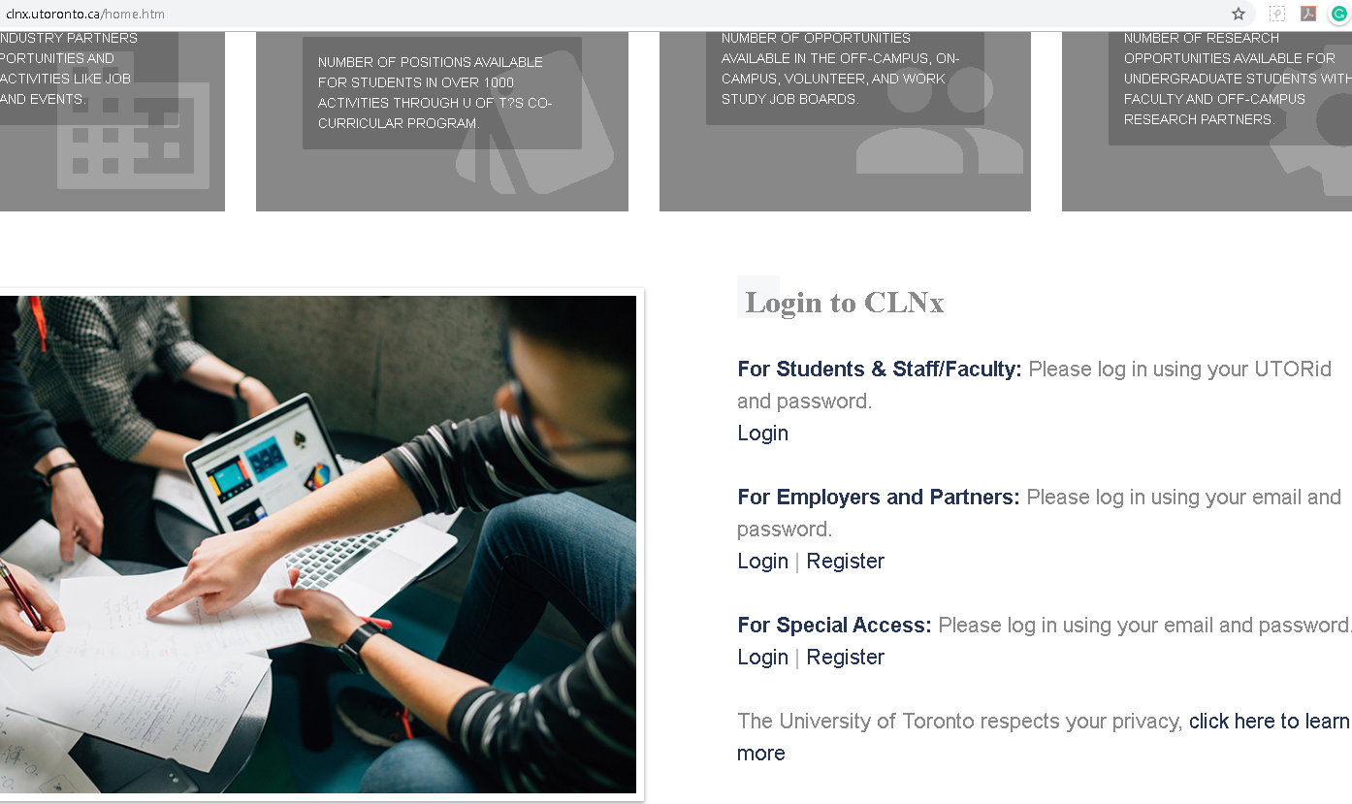

- Select “Experiential Learning” on the secondary navigation bar on the left hand side of the screen (red arrow)
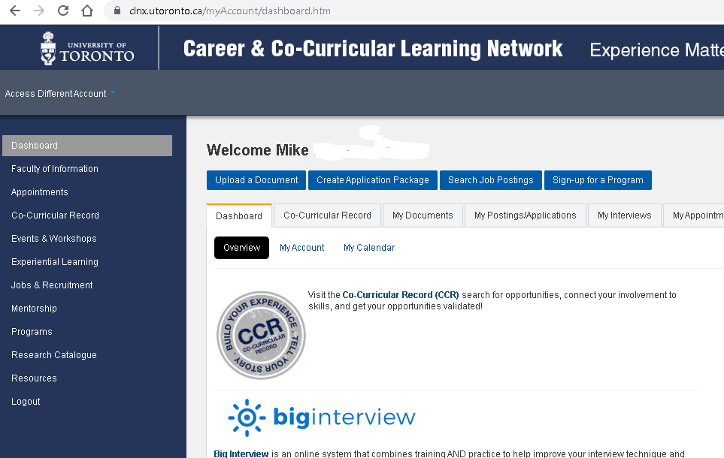
- Select “View” under “Course/Programs” (red arrow)
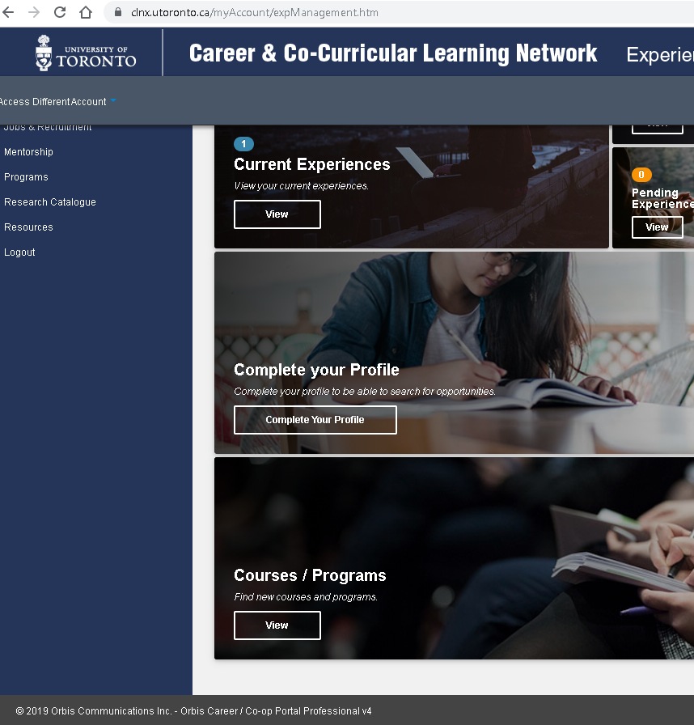

- Select the blue “Apply” button under the “USRP” banner (red arrow)
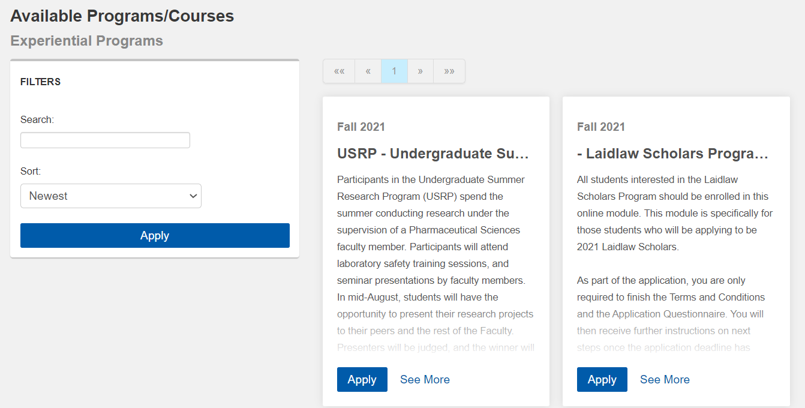
- Once you apply, the USRP will be added to your “Current Experiences” section under “Experiential Learning”.
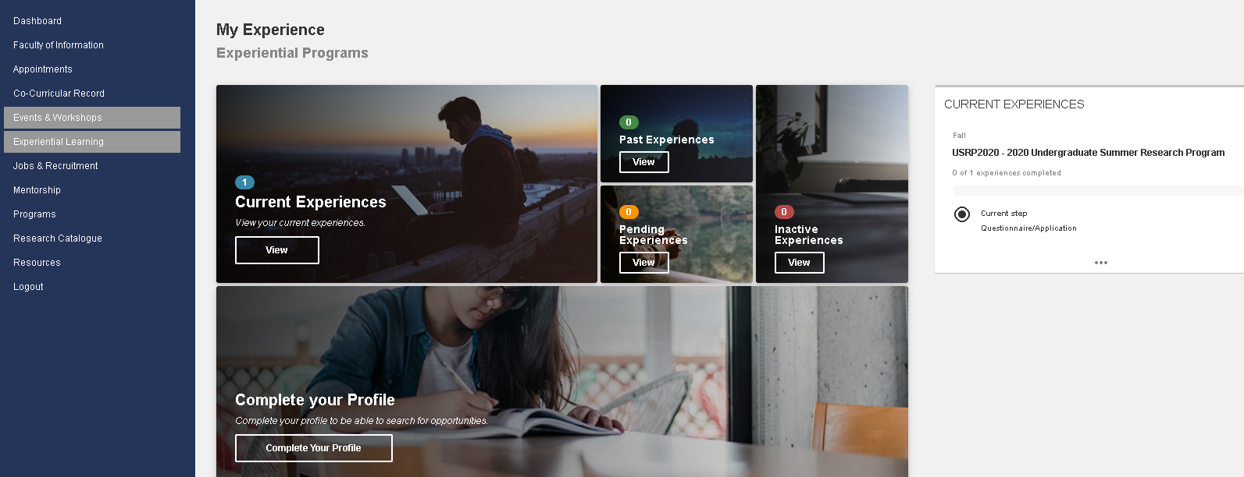
  - * Note: If you have applied to the USRP program, you must enter through the “Current Experiences” section to access opportunities

- Select “Current Experiences” – tap anywhere in the white box (red arrow)
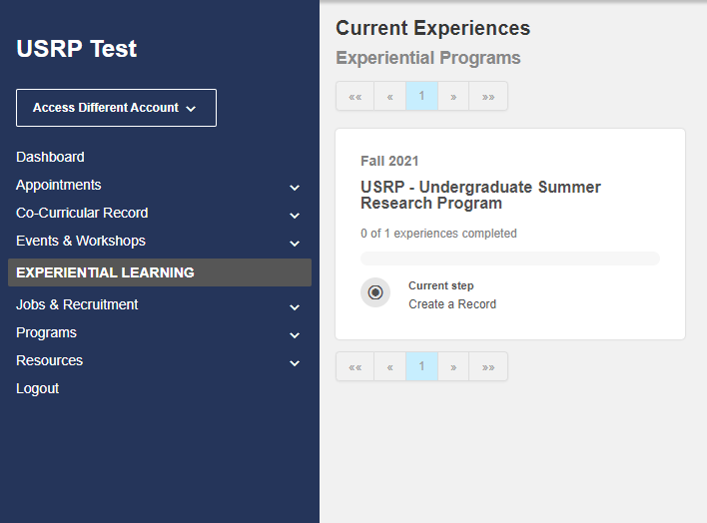

- You will be required to complete two steps in the application process. First is the Questionnaire/Application that will provide our office with the required information for communication and processing. Select the Questionnaire/Application button (red arrow)
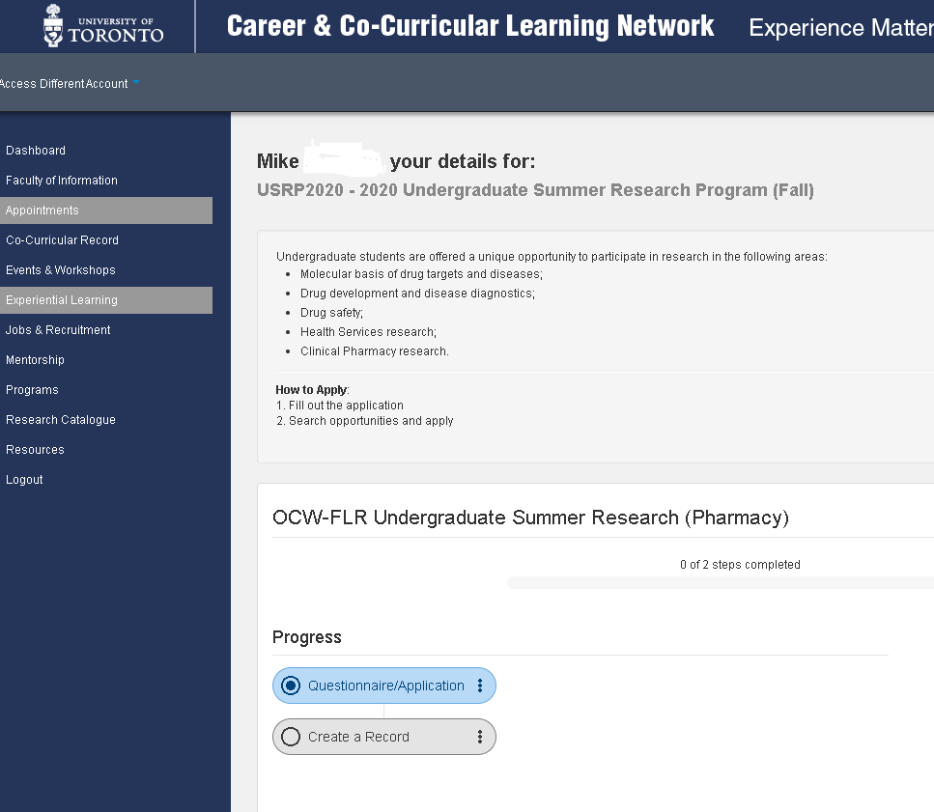

- Select the “Answer Questionnaire” button (red arrow)
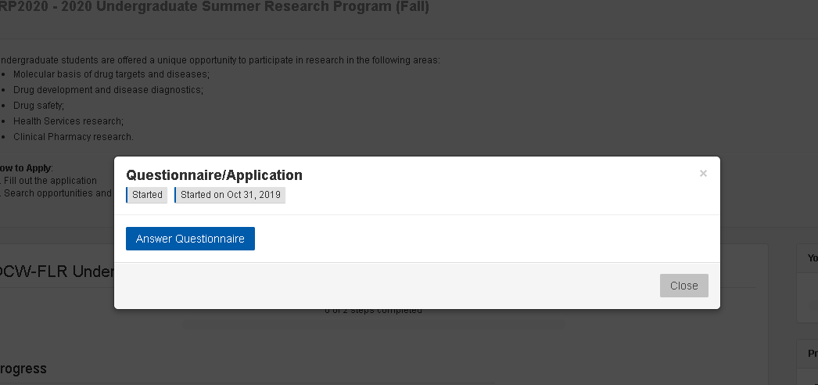
- Complete the questionnaire and enter your current institution (University of Toronto or Other, if ‘Other’ please enter the institution in the free text box).
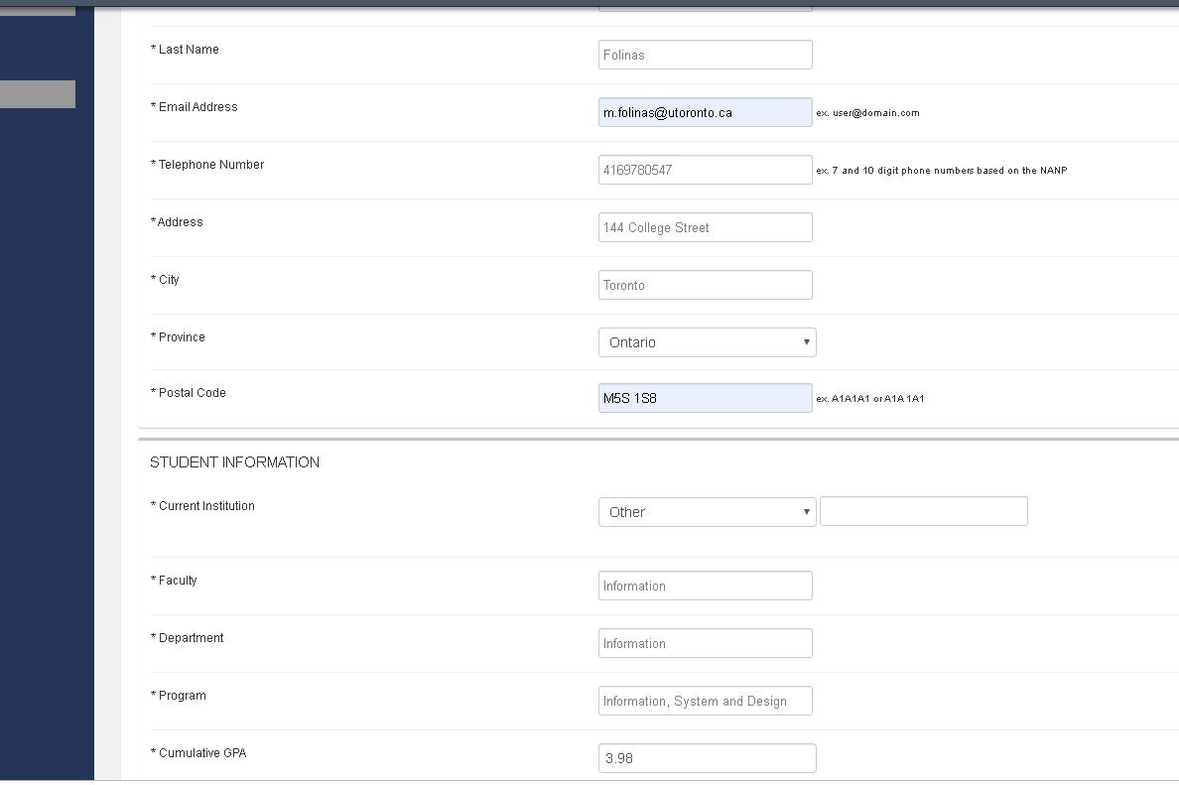
- Click the “Submit” button to move on to Step 2 (Formal application to supervisors)
- You will see the screen below that summarizes your progress.
- Click on the “Create a Record”
- Click on “Search Opportunities” to access the supervisor pages
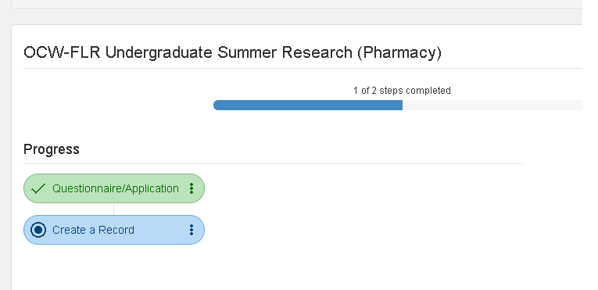
- Scan through the opportunities and click the blue button on the bottom to “View” the details of the position and the potential supervisor.
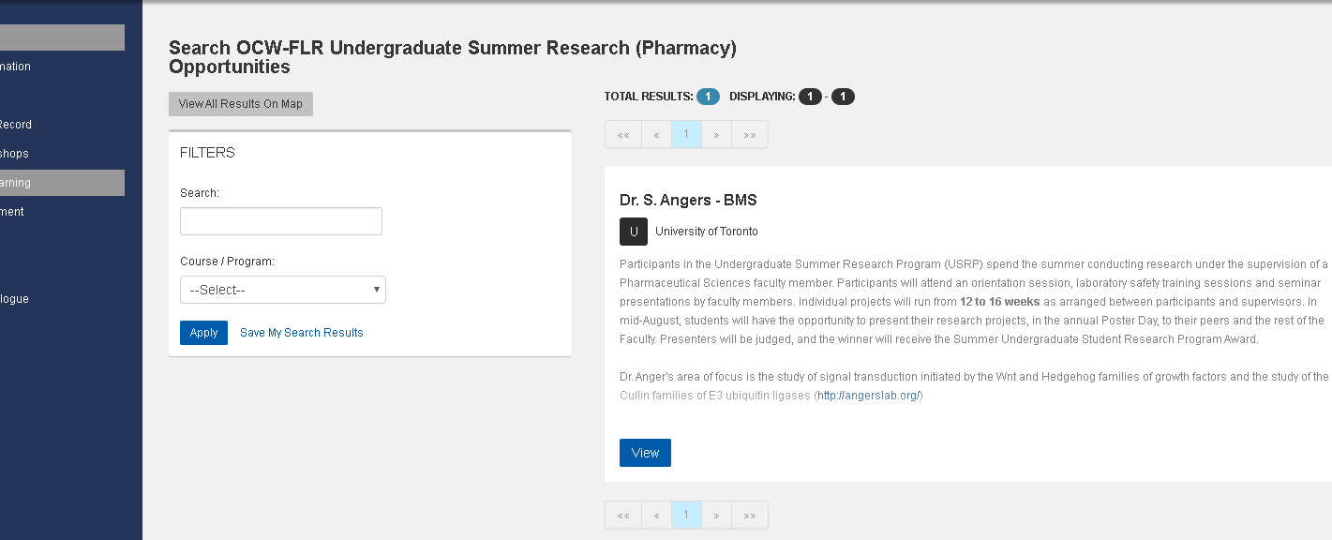
- Please note in the posting, the number of positions available and the closing date of the job posting. The closing date on all postings will be on January 20, 2023 at 11:59 pm EST.
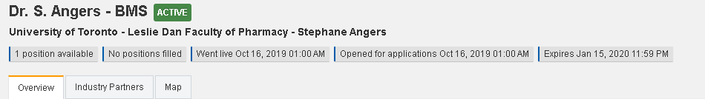
- For each opportunity you apply to (apply up to 5 opportunities, if you apply to more than 5 opportunities, the Research Office will select the first 5 applications and remove all others) you will need to include a Letter of Intent, Curriculum Vitae/Resume and an unofficial transcript. The Curriculum Vitae/Resume and an unofficial transcript will remain the same for each opportunity. You will need to prepare a separate Letter of Intent for each opportunity.
Applying to Opportunities:
- Once you have your documents ready (e.g. saved on your desktop), click on the “Apply” button and click on “Create a new application package”
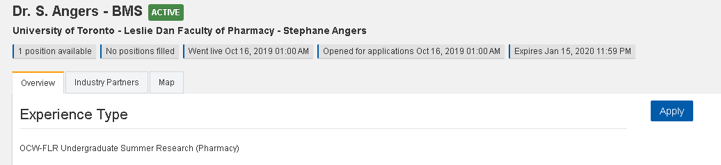
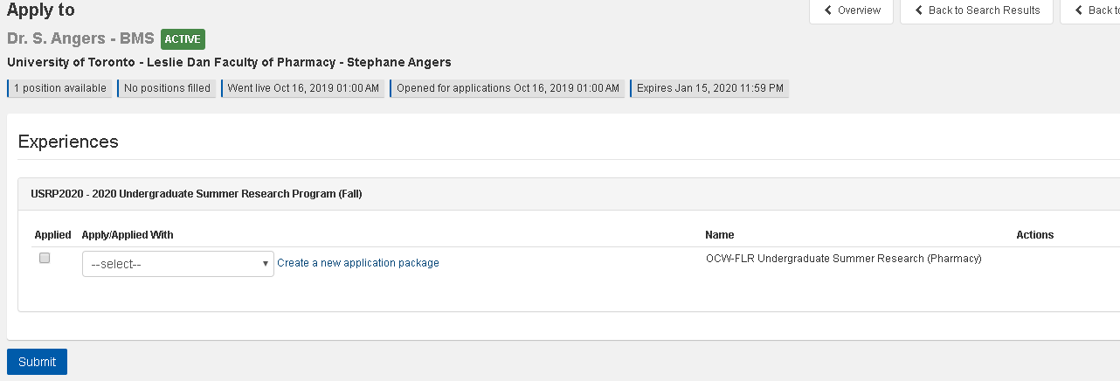
- Click “Upload a document” to add documents to the application package. To upload a document, Label the document with a “Name” (e.g. Mike_F_Resume) and select the appropriate document type.
Click “Upload New file”, Choose file (select the file you want to upload), then click Upload Document.
Repeat these steps for each of the documents. You will only need to upload your Letter of Intent, Resume/CV and Unofficial Transcript.
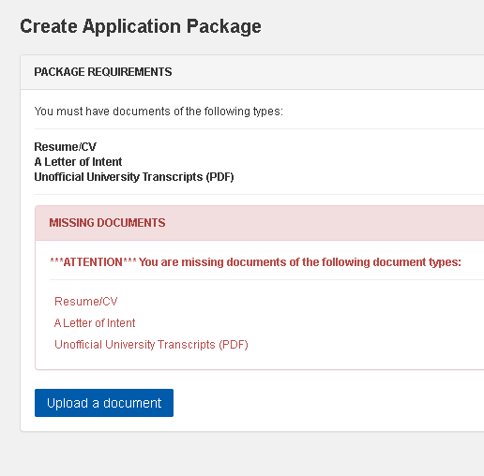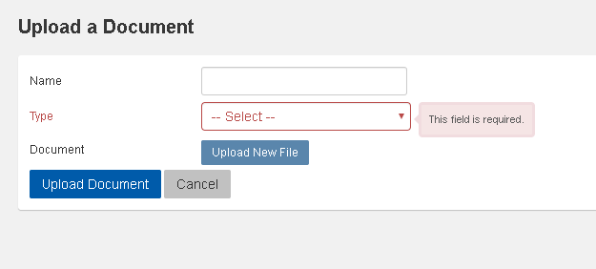
- After you have uploaded all your documents, label your package name with your name and research area of interest so that it is easily identifiable. Select the corresponding documents you uploaded, to be include in the application package and then click on “Submit”. Your Resume/CV and Unofficial Transcript should be available in all other application packages as you only need to upload these once (unless you wish to tailor your application for each opportunity).

* If you your document doesn’t appear as a selectable option click refresh on your browser. You will see any error message which brings you back to the document upload section. Click on cancel to bring you back to the application package page and your document should be available
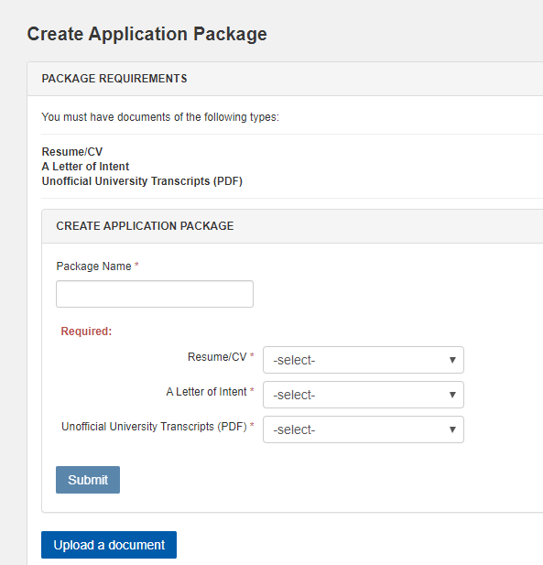

- Select the appropriate application package and click on “Applied” box. Submit to complete the application
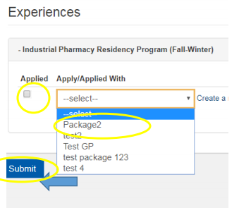
- If you need to withdraw or update your application, go back to the position and click apply and then click on the “remove application button” and reapply
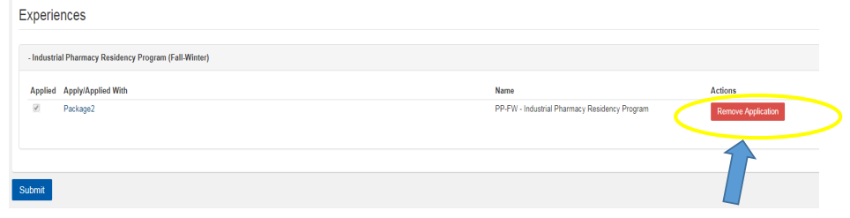

- Apply up to 5 opportunities within your research area of interest. If you apply to more than 5 opportunities, the Research Office will select the first 5 applications and remove all others.

**Note: Once you have submitted your application, you CLNX account will indicate that 1 of 2 steps have been completed. Step #2 is the formal offer from a supervisor, if selected.
No further action is required.

***Note: Submitted applications cannot be altered. If you wish to revise your submitted application, please contact Sam D’Alfonso (sam.dalfonso@utoronto.ca). At your request, your application will be deleted, and you may update a new one with your revisions. Please note that this must be done before the January 20, 2023 deadline.

